

ltlCRETARJAt DEWAN PERWAJOLAN RAKYAT DAERAB

*4M.*  KOTA MALANG

# LEMBAR DISPOSISI

Oi1erlma 1.111gal 23 Jull 2021

TllllPI 06 Juli 2021 Index

 Kode

011cn1Sk111 Kepmla *' U*

Laponn realisui Semesler perllmadll1 Prognosis

1. Yth KcWa Oped Kola Malang '°'""

EnDtbulan Berlkumya Tuun Angpnn 2021 2.

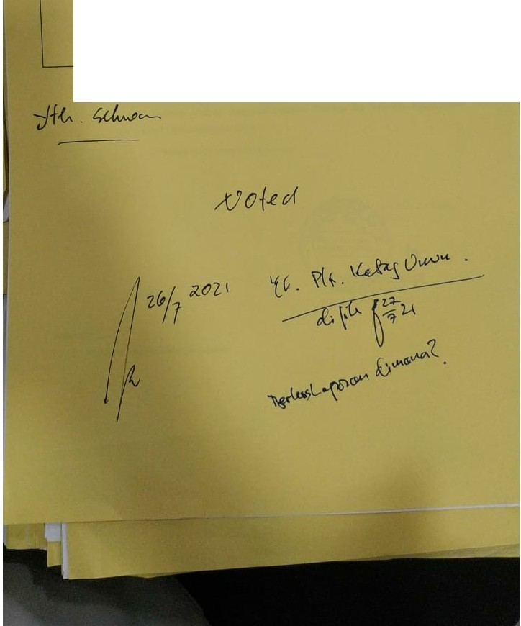

3.

4.

# s.

6.

7.

704